Scenario:

1. Enter transaction code VA01

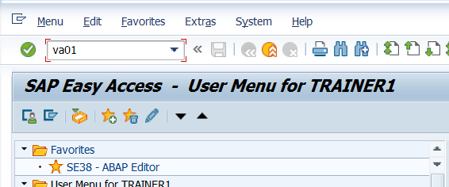

1. Enter the details as shown below and press enter.  
   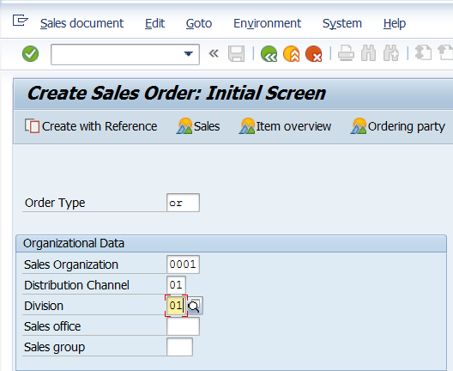
2. In the screen below we see Sold-To-Party. We want to give a default value for it and will create a function exit for the same.

Steps for Function Exit.

1. On the above screen , check System Status

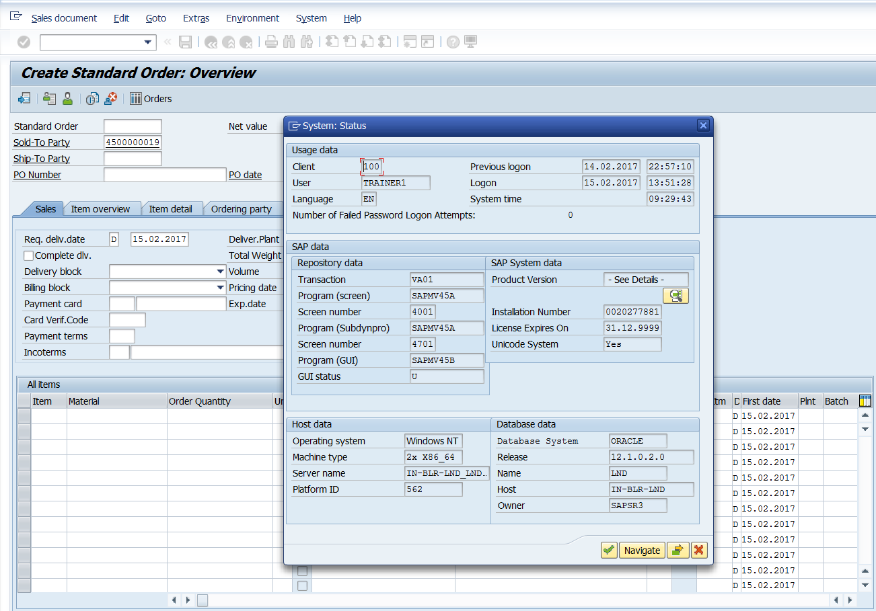

1. Double click on the program name SAPMV45A and it takes us to the corresponding program in SE38. Check the attributes of the program.

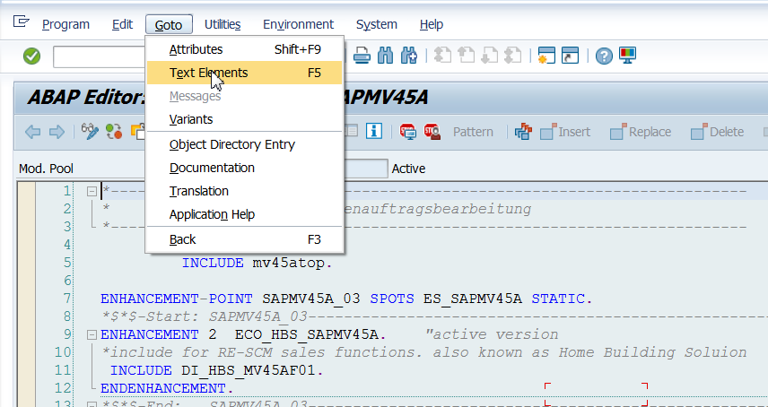

1. Observe the package name.

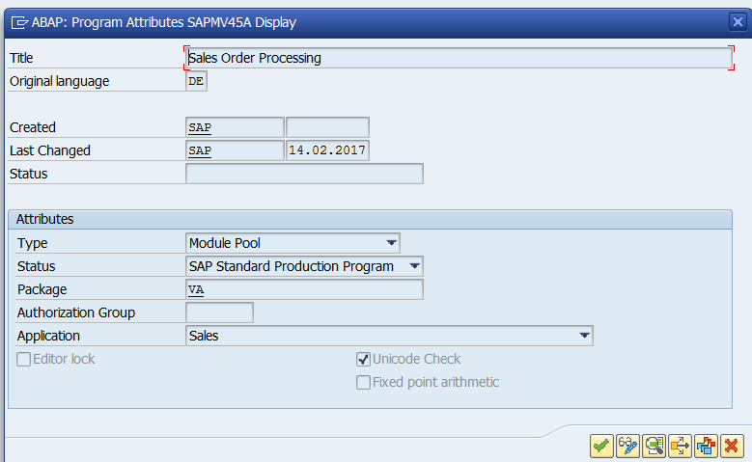

1. Go to SMOD.

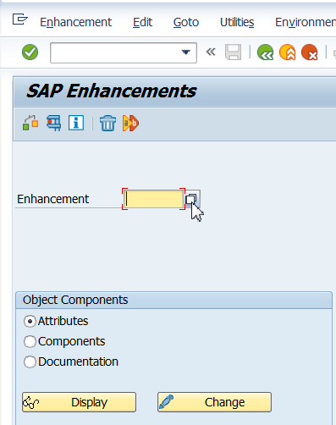

1. Click on Information System.

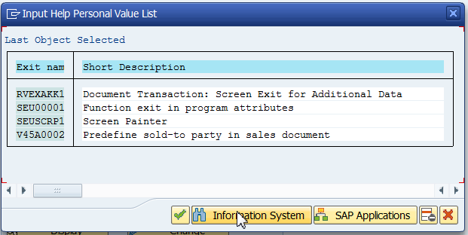

1. Enter package name and click continue.

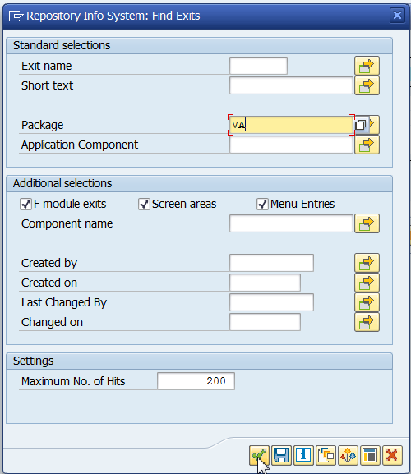

1. Observe the exits.

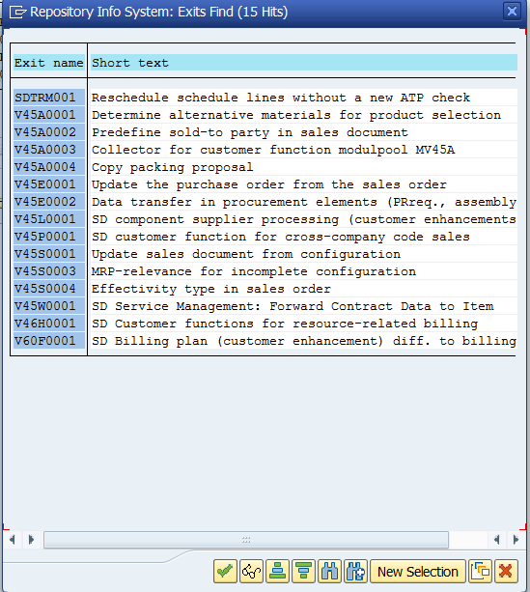

1. V45A0002 is the exit we need to modify.
2. Go to CMOD

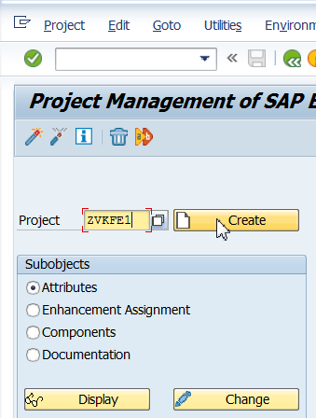

1. Click on Enhancement assignments.

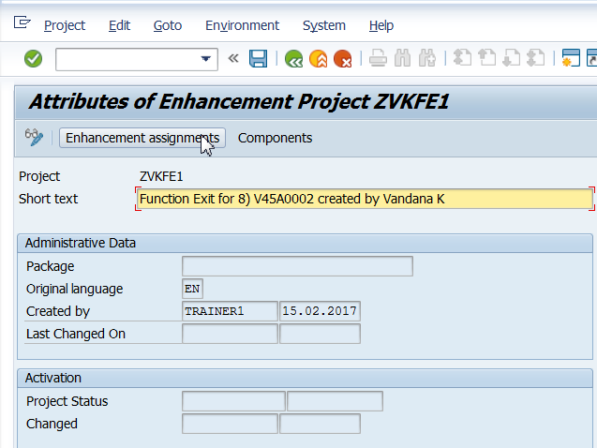

1. Save it in a package or as a local object.
2. Enter the enhancement name as shown below and press enter. The text is automatically displayed.

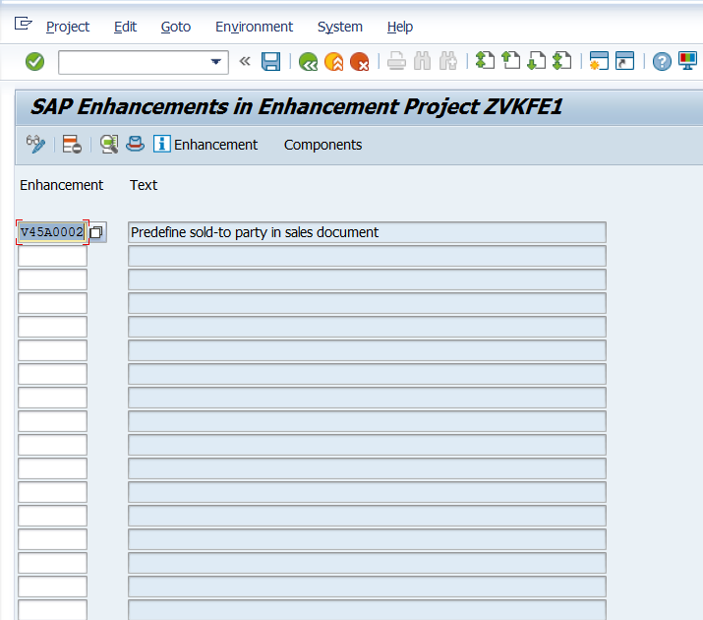

1. Click on components

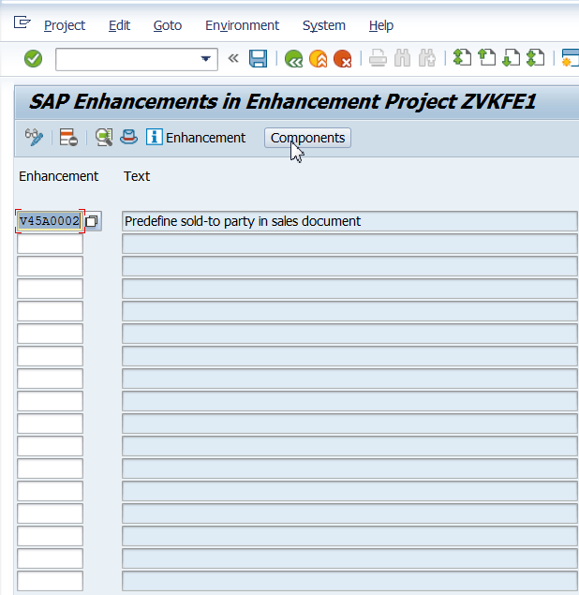

1. Double Click on the exit

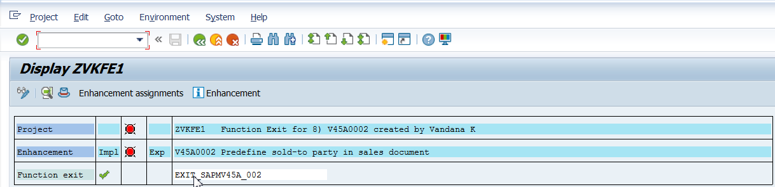

1. Double Click on include.

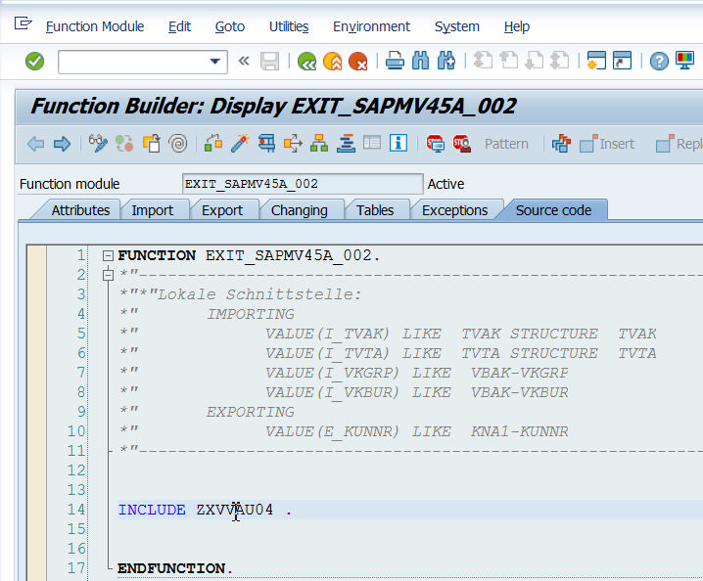

1. Click on Change.

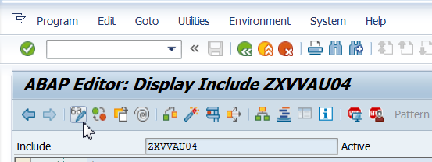

1. Give the value of KUNNR as shown below.

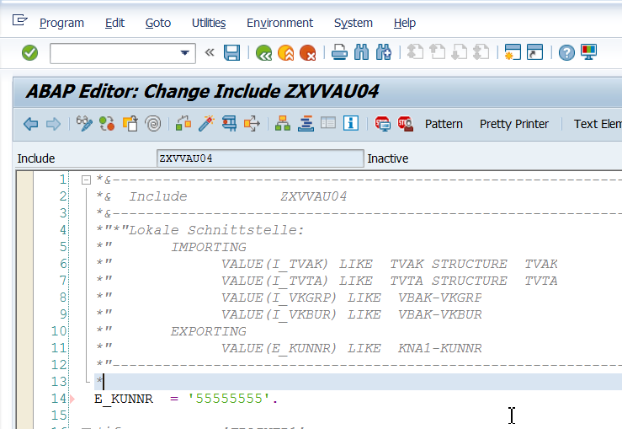

1. Save. Activate. Press F3. Till you reach the below screen and ensure that the exit is activated.

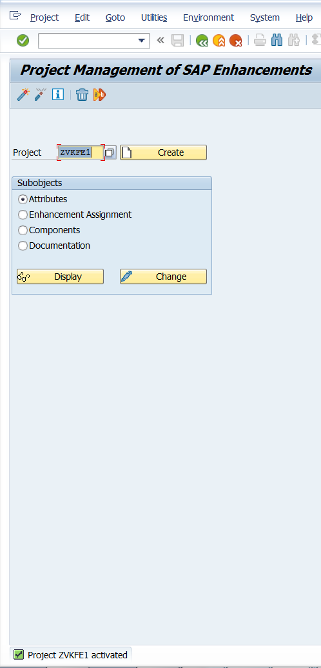

1. Go to VA01 and enter details as shown below and press enter. Observe Sold-To-Party.

